Butterfly Tracking System (BTS)

Use Case Specification Document

UC-3
Create Tagging/Sighting
Version No. 1.1

Project Document Revision History
Version Number | Date | Revision Author | Description of Revision
1.0 | 11/21/2015 | Xiuyan Xin | Initial Release
1.1 | 11/22/2015 | Issam Jassim | Made multiple changes/corrections

Table of Contents

1. Introduction 4
2. Use Case Information 4
2.1 Actors 4
2.2 Use Case Interaction 4
3. Trigger 5
4. Pre-condition(s) 5
5. Post Condition 5
6. Use Case Swimlane (Activity) Diagram 5
6.1 Create Tagging 6
6.2 Create Sighting 7
6.3 Upload Batch File 8
7. Main/Basic Flow(s) of Events (Happy Path) 8
7.1 Create Tagging: 8
7.2 Create Sighting: 9
7.3 Upload Batch File: 9
8. Alternate/Exception Flow of Events 10
8.1 Invalid Data Entered: 10
8.2 Duplicate Tag Number: 10
8.3 Invalid Tag Number: 11
9. Assumptions/Business Rules including Non-Functional Requirements 11
10. Use Case Specification Review and Signoff 12

Introduction
This use case describes the process of entering butterfly tagging and sighting data that is collected by reporters to the system. Registered Users and Administrators have the ability to report tagging and sighting either by adding one new record at a time using the appropriate form or by uploading a batch file to add to process multiple records to the system. In both cases the system will verify the validity of the data before any records are inserted into the database. The system prompts the user with appropriate error messages when necessary to if invalid data is detected. This use case will cover three functionalities as follows:
- Create Tagging: For users to report butterfly taggings.
- Create Sighting: For users to report butterfly sightings.
- Upload Batch File: For users to upload a batch file that contains any number of butterfly taggings and/or sightings to be processed at once.

Use Case Information

Actors
Actor Name | Role | Description
Registered User | Main | Users that have an active account in the system
Administrator | Main | Registered users that have administrator status

Use Case Interaction
Predecessor | Session Management
Successor | Update Tagging/Sighting, Management

Trigger
Functionality | Trigger
Create Tagging | Submit button pressed by user after entering the tagging information (tag number, Date, Location, State, City, Latitude, Longitude)
Create Sighting | Submit button pressed by user after entering the sighting information (tag number, Date, Location, State, City, Latitude, Longitude)
Upload Batch File | Upload button pressed by the user after choosing the batch file from local directory, containing any number of taggings and/or sightings

Pre-condition(s)
A user must be logged in the system to be able to report any butterfly tagging or sighting.

Post Condition
All valid butterfly taggings and sightings will be inserted into the database.

Use Case Swimlane (Activity) Diagram
In this section user refers to both Registered Users and Administrators.

Create Tagging
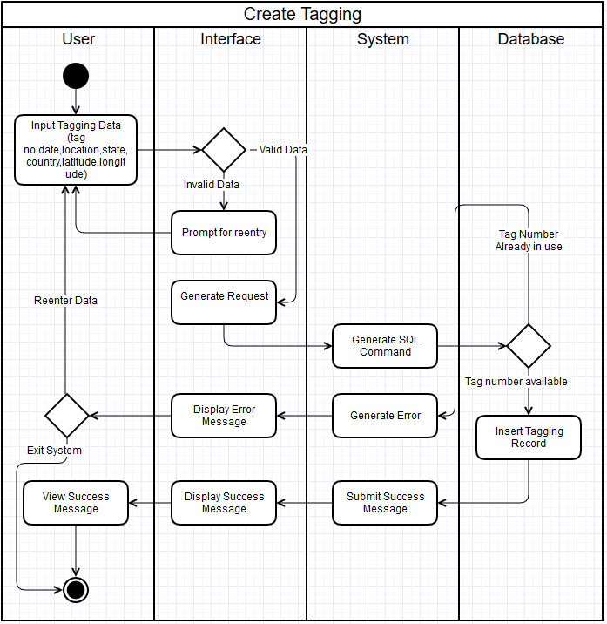
Diagram 6.1 Version 1.1 11/22/2015

Create Sighting
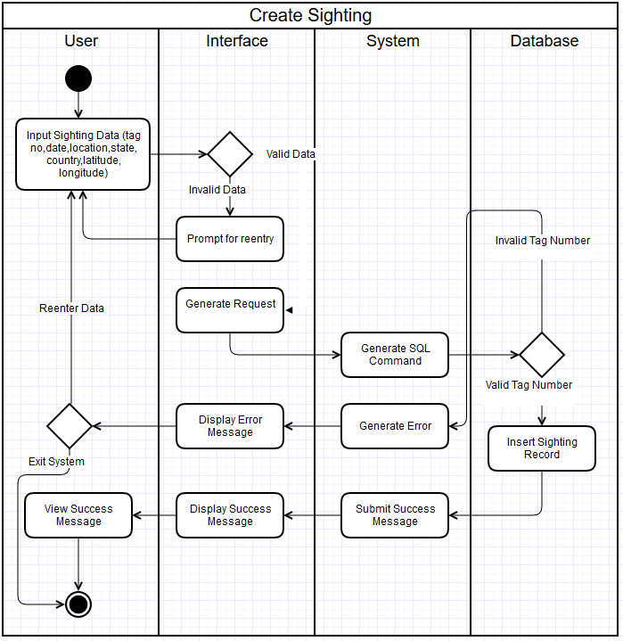
Diagram 6.2 Version 1.0 11/22/2015

Upload Batch File
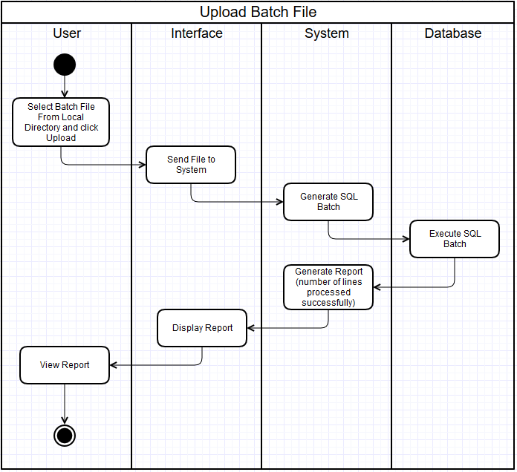
Diagram 6.3 Version 1.0 11/22/2015

Main/Basic Flow(s) of Events (Happy Path)
In this section user refers to both Registered Users and Administrators.

Create Tagging:
Refer to Diagram 6.1 for a visual of this flow.
- The user enters tagging information, including tag number, date, location, state, country, latitude, longitude and clicks submit.
- The interface validates the input data.
- The interface generates request and sends to system.
- The system generates SQL command and sends to database.
- The database will check if tag number is already in use.
- The database inserts tagging record.
- The system will send success message to interface.
- The interface will display success message.
- The user will view success message.

Create Sighting:
Refer to Diagram 6.2 for a visual of this flow.
- The user enters sighting information, including tag number, date, location, state, country, latitude, and longitude, and clicks submit.
- The interface validates the input data.
- The interface generates request and sends to system.
- The system generates SQL command and sends to database.
- The database will check to see if a valid tag number was entered for a previously tagged butterfly.
- The database inserts sighting record.
- The system will send success message to interface.
- The interface will display success message.
- The user will view success message.

Upload Batch File:
Refer to Diagram 6.3 for a visual of this flow.
- The user selects a batch file from local disk and clicks upload button.
- The interface will transfer the data to system.
- The system will generate SQL batch commands for all valid lines in the batch file and sends to database.
- The database executes all batch files that are valid (Available tag number for taggings, and valid tag number for sightings).
- The system generates a report showing the number of lines processed successfully.
- The interface will display the report.
- The user will view the report.

Alternate/Exception Flow of Events
In this section user refers to both Registered Users and Administrators.

Invalid Data Entered:
This flow applies to both Create Tagging and Create Sighting and can be seen in both Swimlane Diagrams 6.1 and 6.2 respectively.
- The user enters information and clicks submit button.
- The interface checks for valid data.
- The interface displays invalid data message and prompts user for reentry.
- The user starts over by reentering data.

Duplicate Tag Number:
This flow applies to Create Tagging and can be seen in Swimlane Diagram 6.1.
- The user enters tagging information, including tag number, date, location, state, country, latitude, longitude and clicks submit.
- The interface validates the input data.
- The interface generates request and sends to system.
- The system generates SQL command and sends to database.
- The database will check if tag number is already in use.
- The database indicates tag is already in use and sends error to system.
- The system will generate error message.
- The interface will display error message.
- The user will view error message and will either exit system or go back to form and starts over.

Invalid Tag Number:
This flow applies to Create Tagging and can be seen in Swimlane Diagram 6.1.
- The user enters sighting information, including tag number, date, location, state, country, latitude, longitude and clicks submit.
- The interface validates the input data.
- The interface generates request and sends to system.
- The system generates SQL command and sends to database.
- The database will check if tag number is valid.
- The database indicates tag is not valid (no tagged butterfly with such number) and sends error to system.
- The system will generate error message.
- The interface will display error message.
- The user will view error message and will either exit system or go back to form and starts over.

Assumptions/Business Rules including Non-Functional Requirements
The browsers that are used to access to the system are modern and capable of properly displaying various forms and reports that are generated by the system.

Use Case Specification Review and Signoff
Review and Signoff of the Use Case Specification
Name | Project Team Role | Signature | Date
Issam Jassim | Team Leader | Ikj | 11/24/2015
Yue Dai | Front-end Developer | yd | 11/24/2015
Xiuyan Xin | Front-end Developer | xx | 11/24/2015
Nesrin Mohammed | Database Manager | nm | 11/24/2015

